Over the next several classes you will learning about nutrients and their roles in the body. This will be a self-directed activity that will include you using your Chromebook and earbuds. You will watch a series of short video clips and answer questions related to the information you view while completing this NUTRIENT FACT SHEET.
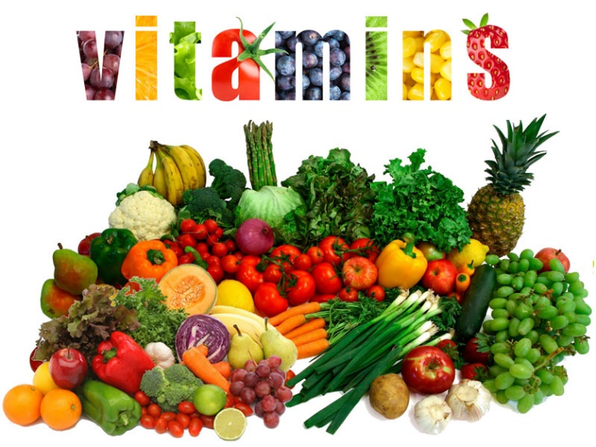
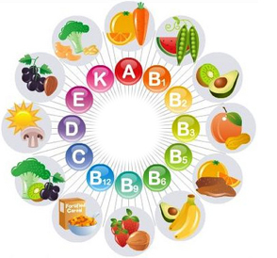
Nutrient Fact Sheet # 6
Vitamins:

https://www.youtube.com/watch?v=ISZLTJH5lYg
- Vitamins are micronutrient (needed in small amounts) and ______________________ compounds (which means they are found only in living things).
- There are two types of vitamins: ____________________ soluble and __________________ soluble.
- What are the 3 differences between lipid (fat) soluble vitamins and water-soluble vitamins.
  - _____________________________________________________________________________
  - _____________________________________________________________________________
  - _____________________________________________________________________________
- List 2 sources of water soluble vitamins: ________________________, ________________________.
- _______________________ soluble vitamins are taken directly into the blood stream.
- _______________________ soluble vitamins are dissolved in fat.
- List 3 sources of fat soluble vitamins: __________________, _________________, _______________.
- What is the name of the acidic substance from the liver that breaks down fat? __________________.
- Fat soluble vitamins are absorbed through the ________________________________ wall.
- How do fat soluble vitamins move around the blood and body? _______________________________
____________________________________________________________________________________
- Water soluble vitamins are excreted in urine by the kidneys and need to be replenished on a ________________________ basis.
- Fat soluble vitamins are stored in the _____________________ and __________________________.
- List 2 functions of B Vitamins:
  - _____________________________________________________________________________
  - _____________________________________________________________________________
- List 3 functions of Vitamin C:
  - _____________________________________________________________________________
  - _____________________________________________________________________________
  - _____________________________________________________________________________
- List 3 functions of Vitamin A:
  - _____________________________________________________________________________
  - _____________________________________________________________________________
  - _____________________________________________________________________________
- List 1 function of Vitamin D:
  - _____________________________________________________________________________
- List 1 function of Vitamin E:
  - _____________________________________________________________________________
- List 1 function of Vitamin K:
  - _____________________________________________________________________________
- List 3 Symptoms and/or diseases related to vitamin deficiency:
  - ___________________________________________________
  - ___________________________________________________
  - ___________________________________________________
- Is it a good idea to take more vitamins than recommended? Why or why not? __________________
___________________________________________________________________________________

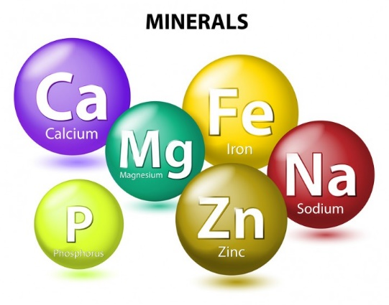
LAST ONE! Over the next several classes you will learning about nutrients and their roles in the body. This will be a self-directed activity that will include you using your Chromebook and earbuds. You will watch a series of short video clips and answer questions related to the information you view while completing this NUTRIENT FACT SHEET.
Nutrient Fact Sheet # 7
Minerals:
https://www.youtube.com/watch?v=v9wBF60-Wj8
- What is the definition of a mineral (yes, write the whole thing!)? _____________________________
____________________________________________________________________________________________________________________________________________________________________________________________________________________________________________________________
- List and define the 2 classifications of minerals:
  - ____________________________________________________________________________________________________________________________________________________________
  - ____________________________________________________________________________________________________________________________________________________________
SORRY, HE SAYS THE MINERAL IRON REALLY WEIRD!
- Iron
  - Function(s) of the mineral in the body: _____________________________________________
  - Source(s) of the mineral: _________________________________________________________
  - What is Anemia? _______________________________________________________________
- Fluoride
  - Function(s) of the mineral in the body: _____________________________________________
  - Source(s) of the mineral: _________________________________________________________

- Iodine
  - Function(s) of the mineral in the body: _____________________________________________
  - Source(s) of the mineral: _________________________________________________________
  - What does an Iodine deficiency cause: _____________________________________________
- Sodium
  - Function(s) of the mineral in the body: _____________________________________________
  - Source(s) of the mineral: _________________________________________________________
- Calcium
  - Function(s) of the mineral in the body: _____________________________________________
  - Source(s) of the mineral: _________________________________________________________
- Potassium
  - Function(s) of the mineral in the body: _____________________________________________
  - Source(s) of the mineral: _________________________________________________________
https://www.youtube.com/watch?v=SHvQOzeDK8A
- The American Academy of Pediatrics recommends _________________________________________, ____________________________________, and _____________________________________ to help develop strong bones.
- List 3 sources of calcium and vitamin D rich foods: _________________________________, _____________________________________, _______________________________.
- List 3 examples of weight bearing exercise: ___________________________________, _____________________________________, ___________________________________.

