Over the next several classes you will learning about nutrients and their roles in the body. This will be a self-directed activity that will include you using your Chromebook and earbuds. You will watch a series of short video clips and answer questions related to the information you view while completing this NUTRIENT FACT SHEET.
Nutrient Fact Sheet #1
Nutrients:
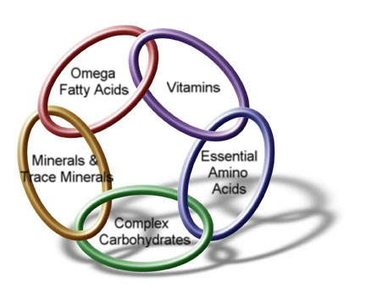
Nutrient Basics
https://www.youtube.com/watch?v=BnoHbd-9lGY
What are nutrients: ___________________________________________________
_____________________________________________________________________
5 possible ways your body uses Nutrients:
1.__________________________________________________________________
2.__________________________________________________________________
3. __________________________________________________________________
4. __________________________________________________________________
5. __________________________________________________________________
What are the 6 Basic Nutrients:
1.____________________________ 2.____________________________
3. ____________________________ 4. ____________________________
5. ____________________________ 6. ____________________________
Calories:
Calories
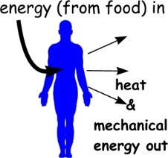
https://www.youtube.com/watch?v=r5BxTG3YVe4
What are Calories: _________________________________________________
_________________________________________________________________
3 Facts about calories: 1.__________________________________________________________________________________ ____________________________________________________________________________________
2._____________________________________________________________________________________________________________________________________________________________________
3._____________________________________________________________________________________________________________________________________________________________________
Nutrient Dense:
Nutrient Dense Foods
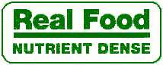
https://www.youtube.com/watch?v=j82oa4Xmys0
AND (watch both videos)
https://www.youtube.com/watch?v=qzFHuhlw-xc

What is a nutrient dense food? ____________________________________________________________________________________________________________________________________________________________________________________
How can you achieve nutrient balance in your diet?
____________________________________________________________________________________________________________________________________________________________________________________
Examples of foods that are nutrient dense:
__________________________________________________________________________________________
__________________________________________________________________________________________
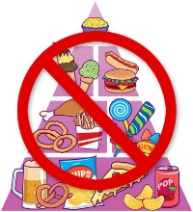
Empty Calories:
Empty Calories
https://www.youtube.com/watch?v=x9UG246e414

AND (watch both videos)
https://www.youtube.com/watch?v=HR2Gip3LooU

What are empty calories:
____________________________________________________________________________________________________________________________________________________________________________________
List three Food Examples that contain empty calories: _____________________________________________________________________________________
What is a negative effect on the body when you eat too many empty calories?
_____________________________________________________________________________________
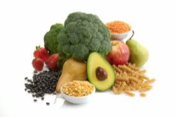
Fiber:
Fiber
https://www.youtube.com/watch?v=nENjgHcBOb0

What is fiber:
__________________________________________________________________________________________
__________________________________________________________________________________________
What are the differences between soluble and insoluble fiber?
__________________________________________________________________________________________
__________________________________________________________________________________________
__________________________________________________________________________________________

List 4 benefits of consuming fiber:
- _______________________________________________________________
- _______________________________________________________________
- _______________________________________________________________
- _______________________________________________________________
List several fiber rich Food Sources:
__________________________________________________________________________________________
__________________________________________________________________________________________

